RW3U6 Pressure
R1 Vocabulary Preview
- pressure un.压力，紧张；气压/v.强迫
pressured adj.（感到有）压力的
- achievement: n.成就
=accomplishment=success
remarkable/brilliant/outstanding achievements
卓越成就
- achieve: v.完成;达到
=accomplish
achieve/accomplish/fulfill/reach one’s dream
实现某人的梦想
- ambition: n.追求；野心；雄心
=determination/drive
aim v.瞄准 n.目标
ambitious: adj.有野心的；雄心壮志的 =determined
ambitious target/aim
有野心的目标
- compare: v.比较
compare with… 和……相比（相同东西 找差异度）
compare…to… 把……比作……（不同东西 找联系）
comparison: n.比较；对照
- apples and oranges 两个无法相比的事物
cats and dogs 瓢泼大雨
It rains cats and dogs.
=It rains heavily.
- lifestyle n.生活方式
- work-life balance n.工作生活平衡
- insist: v.坚持认为；坚决主张
insist on sth./doing sth. 坚持……
insist (that) sb (should) do… 坚持(认为)……
- confirmed: adj.确认的; 坚定的
confirm: v.确认 ensure/make sure
- focus: n.中心点；聚焦点 core
v.专注；聚焦 concentrate
focus on…=concentrate on… 专注于……
focused: adj.有明确目标的;注意力集中的
- media: n.媒介；媒体
social media 社交媒介
- theory: n.理论
..., the theory is that... 理论是，表示是，意思是……
…, so the theory goes. 理论上是这样。
Put the theory into practice. 理论付诸实践。

R2 Vocabulary Preview
- celebrity: n.名流;名人 famous people
celebrity chef 名厨
celebrity gossip 明星八卦
- last: v. 持续 keep/go on/carry on
adj. 最近的；最后的；上一个
Last but not least,… 最后但同等重要的是……
the last straw (压死骆驼的)最后一根稻草
- limited: adj.有限的；受限的 =restricted
limit: v. 限制 restrict/ n. 限制;界限
speed limit/time limit 限速/限时
- status: n.地位，身份; 情形，状态
have a high social status 拥有很高的社会地位
- youth n.青少年时期
young adj.年轻的
- childhood n.童年
名词后缀suffix：
-hood：
neighborhood 邻里，社区
manhood 男子气概
womanhood 女性气质
brotherhood 兄弟情谊
motherhood 母性
- satisfaction n.满意
satisfy v.使满意；满足
satisfy one’s need/demand 满足某人的需求
satisfied adj.满意的
- put in 投入
- apparent [əˈpærənt] adj.明显的，显而易见的
=clear=obvious=evident=transparent
It is apparent to sb. that… 对某人来说……是明显的
- dramatic: adj.戏剧（性）的; 突然的
in a dramatic way 夸张地
drama n.戏剧; 戏剧性事件
dramatically adv.戏剧地; 显著地
- shift: n. 转移；转变；改变/v. 转变；轮班
dramatic shift 戏剧性转变
- highlight: v.突出，强调/n. 最好的部分；提亮；高光时刻
highlighter: n.荧光笔
- realistic adj.现实的，务实的

Vocabulary development-Hedging and Boosting
We can use a range of expressions to make an opinion stronger or weaker.
Hedging (make weaker) | Boosting (make stronger)
- possibly  - may  - might  - not sure that…  - not certain that…  - it is believed that…  - it is thought to be… | - certainly  - clearly  - definitely  - absolutely  - surely  - there is no doubt that…

Grammar – Present conditionals
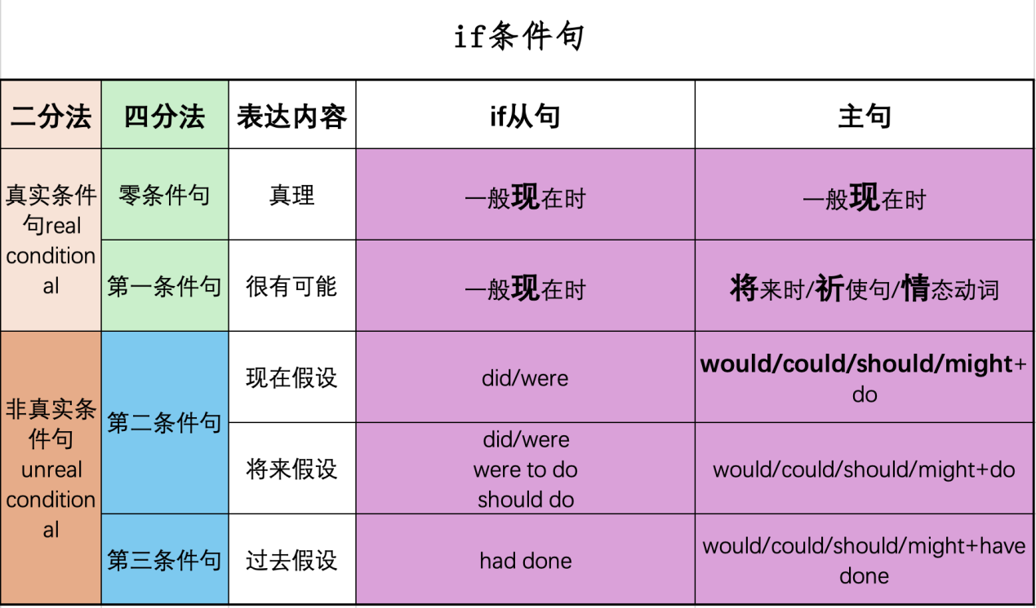

Writing skill
👉 We can use a range of languages to link cause and effect.
